School Energy Audit
Please do this audit for each room in the school, including classrooms, and special rooms such as the library, cafeteria, and the gym. Use your tools found in your tool kit. Have fun being energy detectives!

Classroom: _____________________________________Students:________________________________
Office Equipment
Object | Is it turned off/unplugged  when not being used? | How many watts does it use when on? Use your kill-o-watt to find out.
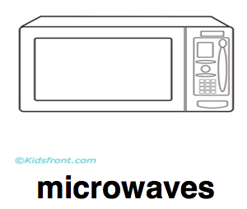
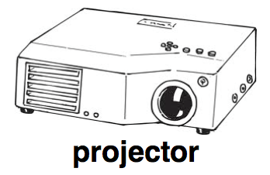
Smartboard
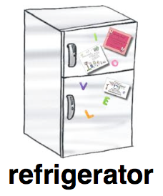
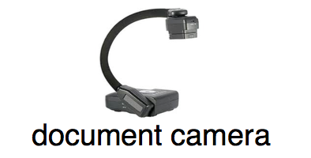
(boxes for other items)

Lighting
Are the lights controlled by a motion sensor? | Yes No
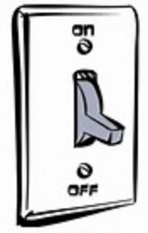  Are the lights on or off? | On Off
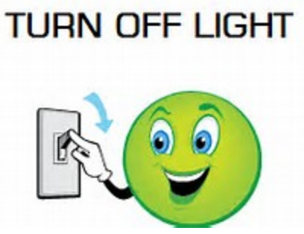  Is there a reminder sign to turn them off? | Yes No
Is there day lighting? | Yes No
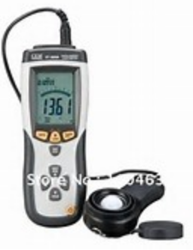  What is the lighting level in the  room? (Use your light meter!) | Lux/ Footcandles
Is the light level high or low? | High Low
How many windows are in the room?
# of windows with coverings (blinds, curtains)
Types of light bulbs (Circle the picture of the lights found in the room). |  |  | 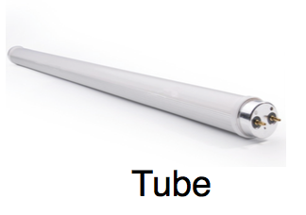 | Other
How many of each kind are in this room?
Types of Lighting
Heating/Cooling
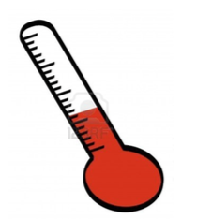
What is the temperature of the room?
Use your thermometer!
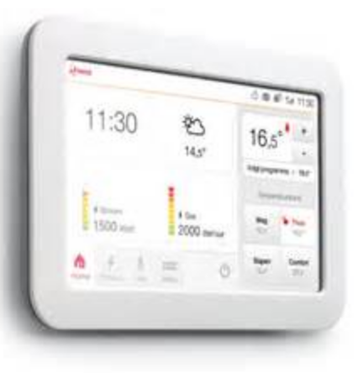
What does the thermostat
say the temperature is?
Can the teacher control how hot or cold the room is? | Yes No
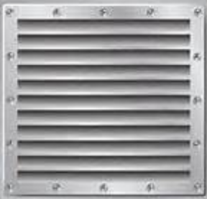  Are the spaces around vents being blocked? | Yes No
How many doors to the outside does this room have?
If there are outside doors, do they have weather stripping?

Final Step: Testing Appliances/Final Evaluation
Do the next two pages when the rest of the audit is finished.
Use your kill-o-watt: Test 6 items in your school that you think use a lot of energy. You can choose the ones you tested already or choose new ones! Use your kill-o-watt in your tool kit to test each item for 6 minutes. Multiply your answer by 10 to figure out how many watts it uses in 60 minutes.
Item | Watts (6 minutes) | Watts (60 minutes)
Which item uses the most electricity?

Did it surprise you? Why or why not?

School Evaluation : Final Step
What 3 things could teachers and students do to make your school more energy efficient?
1.
2.
3.
What grade would you give your school when it comes to energy efficiency?
A B C D F
Why?

