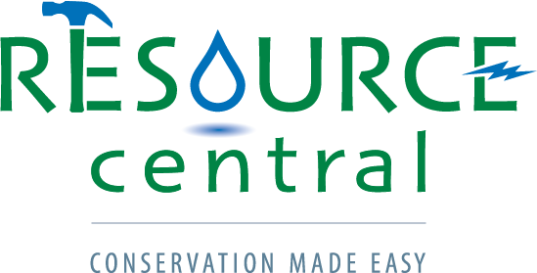

Job Title: Water Programs Manager
Employer: Resource Central; Boulder, CO
Job Status: Full-time, Exempt
Reports To: Program Director: Water & Energy

About Resource Central
We’re thirty people in Boulder determined to make conservation so simple that people don’t even realize they’re doing it. Founded in 1976, our nonprofit’s programs in water, energy, and waste have helped more than 500,000 people improve their homes, conserve natural resources, and save money. Learn more at: ResourceCentral.org.
Job Purpose
Water is one of the most important issues facing Colorado – and we’re looking for a proven leader to help expand our water saving throughout the region. Resource Central, through a variety of popular conservation programs and in partnership with over 30 municipalities, helps homeowners across the Front Range learn about and practice water conservation and sustainable landscaping. With a goal of conserving one billion gallons of water by the year 2020, Resource Central is at the forefront of empowering Colorado residents to use less water through our assortment of approachable, practical, and fun program offerings. The Water Programs Manager will be responsible for providing leadership, staff supervision, and day-to-day management for an emerging program area focused around turf removal and landscape change which includes hiring teams of field staff to remove a portion of lawn at participating residences. We seek an energetic environmental entrepreneur to develop a new program and take on a variety of unique efforts related to water conservation.

Resource Central provides tremendous benefits including: health, dental, vision, life insurance, 403b retirement plan with match, generous paid time off and paid holiday offerings, reimbursement on a fitness membership, free bus pass and more.
Principal Responsibilities
The essential duties of this position include, but are not limited to, the following:
- Develop strategic direction, operational guidelines and growth strategy for a new turf removal program in 2020 with a focus on scalability.
- Meet all impact and financial goals, as an important part of Resource Central’s water programs mix and demonstrate effective day-to-day program management.
- Oversee and manage other programs and efforts related to landscape change as assigned.
- Hire and supervise program staff and volunteers.
- Establish and maintain partnerships with existing key program partners, as well as new partner development.
- Analyze program systems, processes and procedures and implement improvements. Document all processes.
- Provide financial management for programs and have responsibility for Profit and Loss statements.
- Track and monitor program metrics to ensure objectives and goals are met, and proactively communicate and report program information
- Create and implement a marketing plan to meet or exceed all goals of program participation.
- Devise continuous system improvements, leading to improved program impact and efficiency.
- Be an active participant in all water program areas that leads to increased impact, success and recognition for Resource Central’s water program work.

Skills and Abilities
- Proven success developing or growing high impact programs or projects.
- Ability to take initiative, solve problems and manage projects independently.
- Superior communication skills and attention to detail.
- Strong critical thinking and strategic thinking skills.
- Ability to prioritize and multitask effectively.
- Ability to supervise and motivate staff and volunteer work force.
- Excellent computer skills.
- Familiarity and/or experience with water conservation, irrigation systems, and landscaping strongly preferred.

Qualifications
- Must have experience leading a project or program with minimal supervision and a track record of program growth and financial success.
- Must have valid driver’s license and access to a reliable vehicle. Travel to other Front Range cities occasionally required.
- Must be able to complete physical labor, including being able to safely lift a maximum of 30lbs and walk 3 miles at a time. While the role is primarily based in our Boulder office, must be willing to work outside in most conditions, as needed.
- Additional time may be required, including occasional weekend and evening work.
- Bachelor’s degree preferred.
- Minimum of 2-3 years of work experience in program management/coordination.
- Experience developing, tracking or managing budgets.
- Experience leading marketing efforts and gaining buy-in from multiple stakeholders to accomplish shared goals.

To apply please send a cover letter and resume to HR@resourcecentral.org with the subject line “Water Programs Manager”

Resource Central is dedicated to equal employment opportunities. We provide equal employment opportunities to all individuals based on job‐related qualifications and ability to perform a job, without regard to age, sex, sexual orientation, race, color, religion, national origin, disability, marital status, military status, gender expression, genetic information or any other classification protected by applicable state or local law. It is our policy to maintain a non‐discriminatory environment free from intimidation, harassment or bias based upon these grounds.

